NST21022 - Practical for Network Switching and Routing
Department of Information and Communication Technology
Faculty of Technology
Lab sheet :18E1&E2
Reg. Number: SEU/IS/20/ICT/084
Academic Year :2020/2021
Practical No :18

Title: Configure a Wireless LAN
Aim:
• Getting familiar with Wireless Network
• Getting familiar with WPA2 Enterprise WLAN on the WLC

Task:
• Configure wireless router
• Connect wireless devices to the wireless router
• Add an access point to extend wireless coverage
• Configure a new VLAN interface on a WLC.
• Configure a new WLAN on a WLC.
• Configure a new scope on the WLC internal DHCP server.
• Configure the WLC with SNMP settings.
• Configure the WLC to user a RADIUS server to authenticate WLAN users.
• Secure a WLAN with WPA2-Enterprise.
• Connect hosts to the new WLC.

Activities

Exercise 01: Configure Personal Wireless LAN

Use “NST21022 Lab sheet 18E1.pka” file

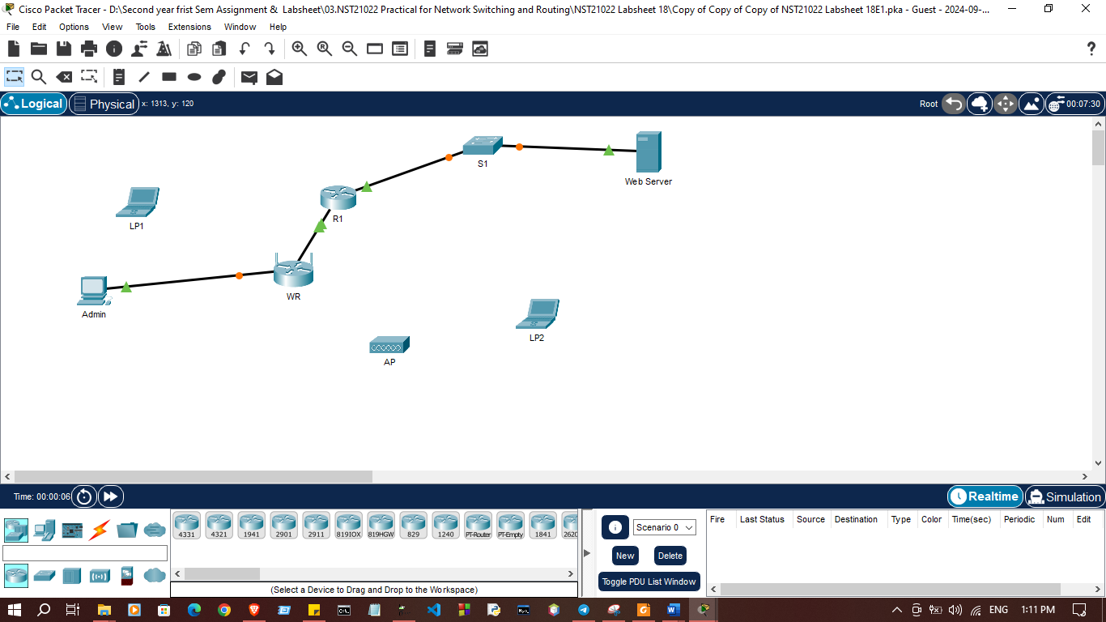

- Configure Admin to use DHCP
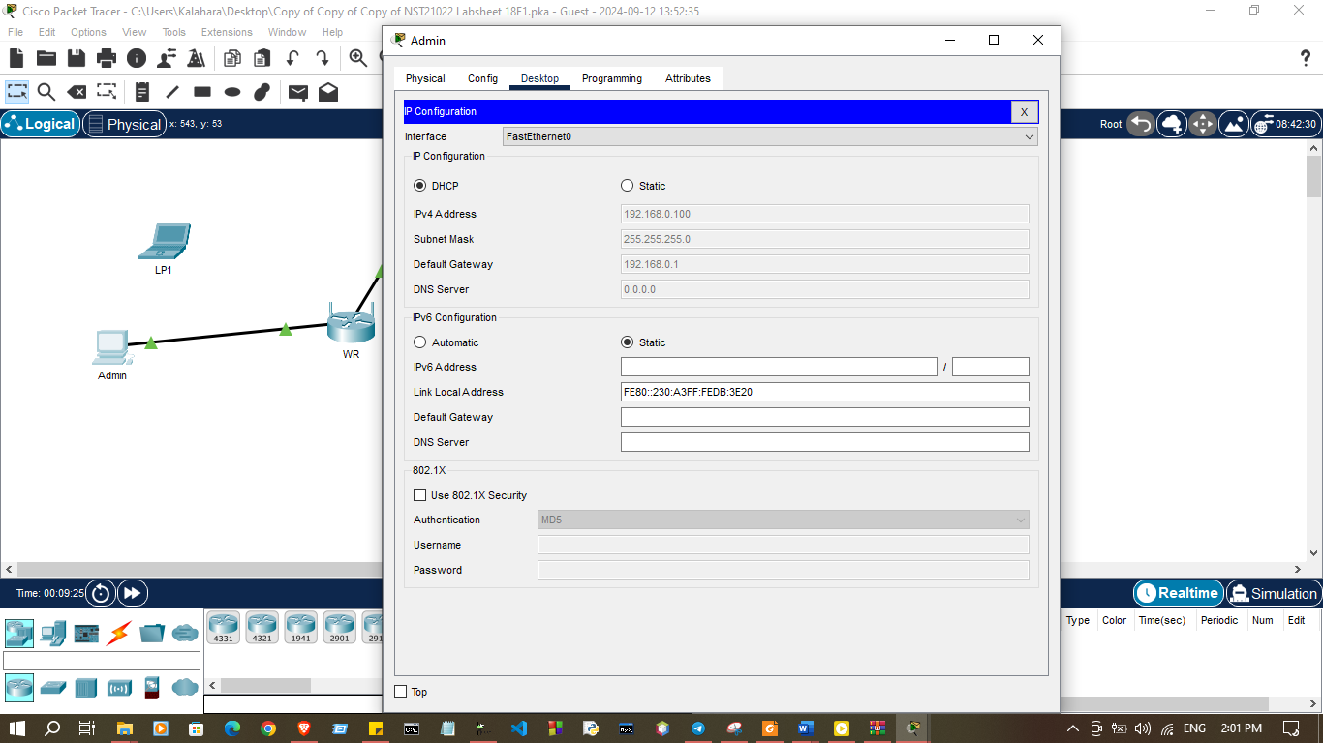

2. Connect to the WR Web Interface (192.168.0.1)

a. In Web Browser
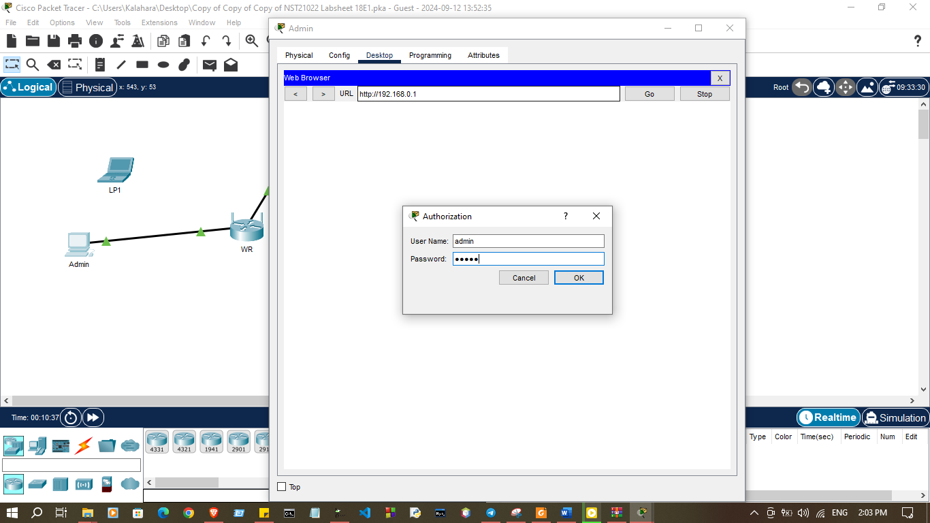
b. Use admin for both username and password

.
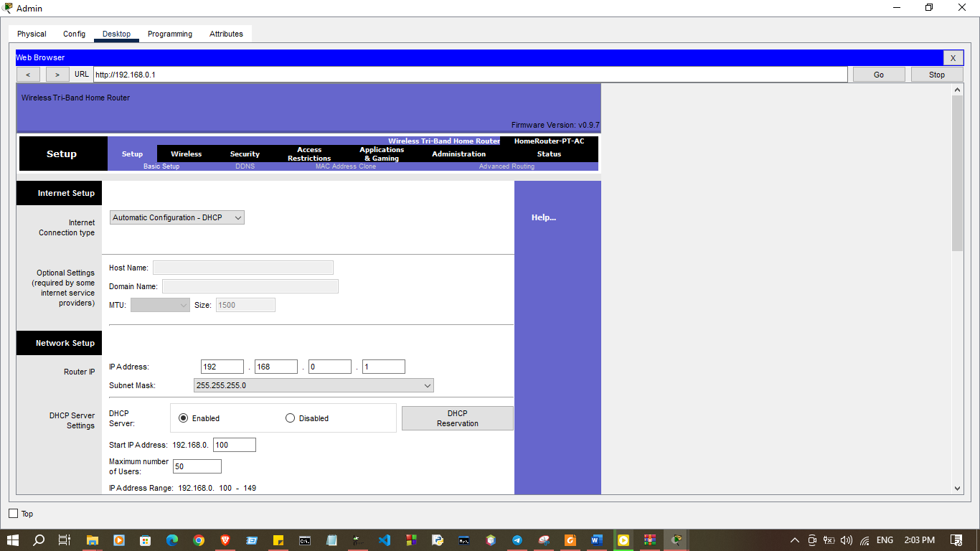
c. Under the Network Setup heading on the Basic Setup page, notice the IP address rang for the DHCP server.

3. Configure the Internet Port of WR
a. Under the Internet Setup at the top of the Basic Setup page, change the Internet IP address method to Static IP

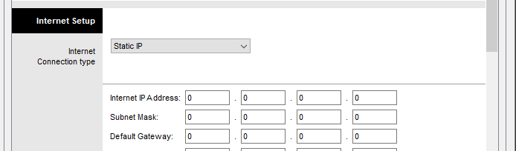

b. Following IP address have to be assigned to the Internet interface:

Internet IP address : 10.1.2.10
Subnet Mask : 255.255.255.0
Default Gateway : 10.1.2.1
DNS Server : 10.1.1.10
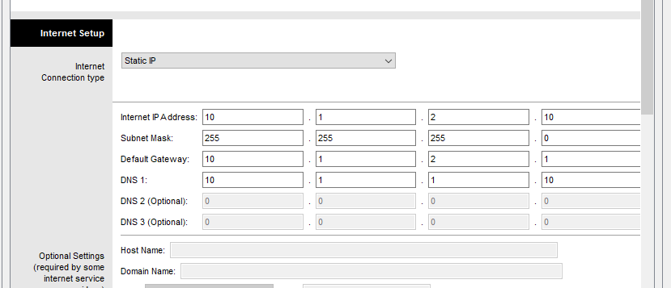

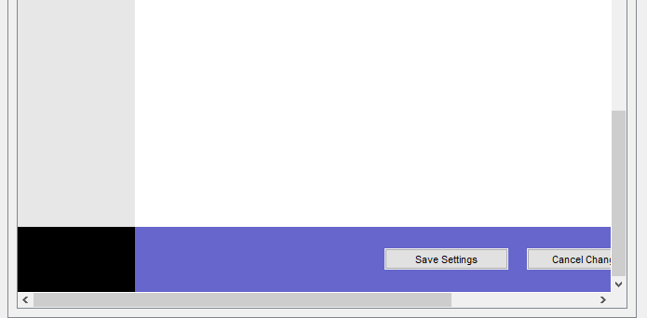
c. Save Settings and verity connectivity through access www.cisco.com

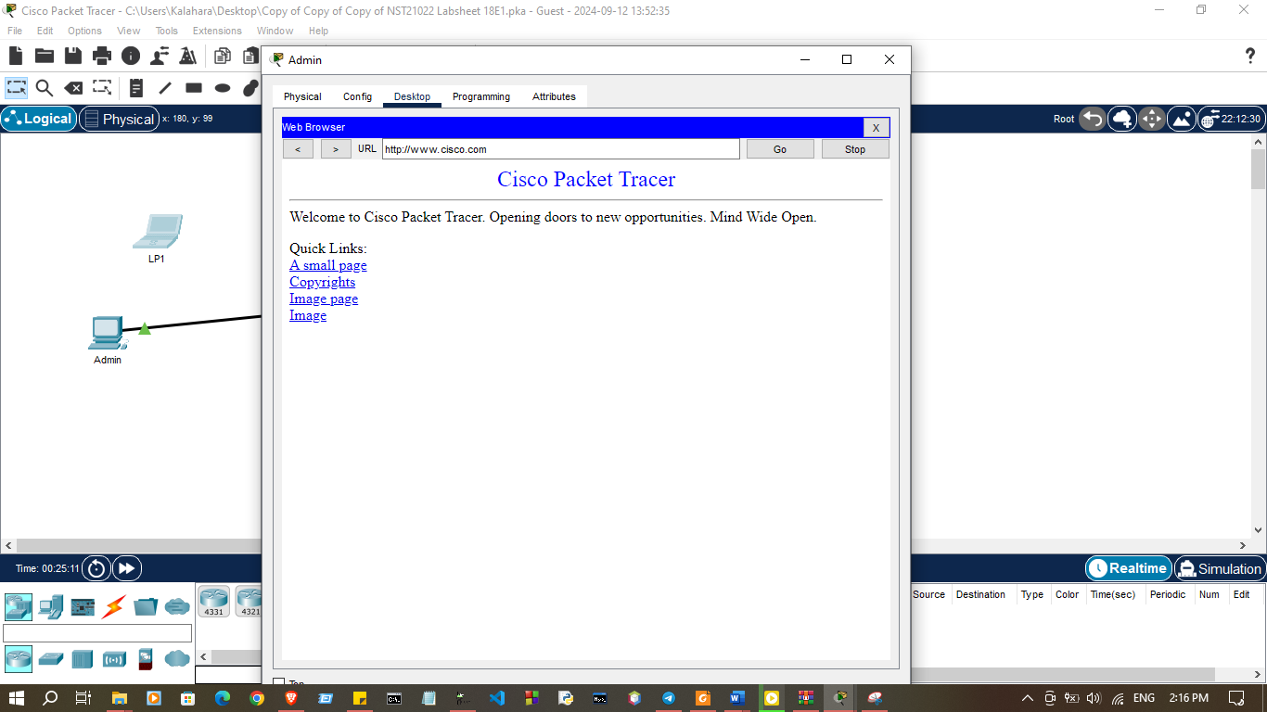

4. Configure Wireless Settings
a. Connect to the WR web interface

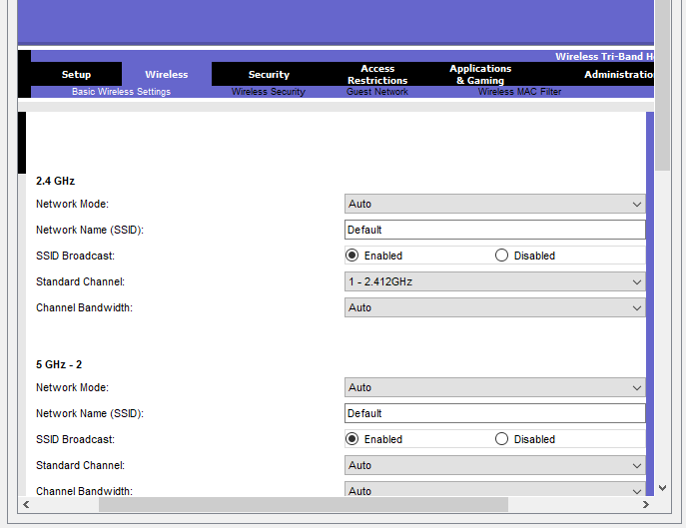

b. Navigate to Wireless Basic Wireless Settings

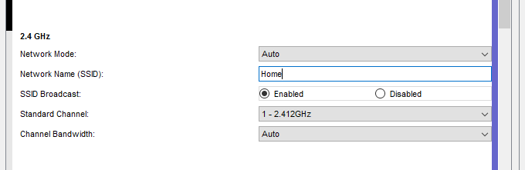
c. Change Network Name (SSID) to Home for only 2.4GHz. tice that SSIDs are case sensitive

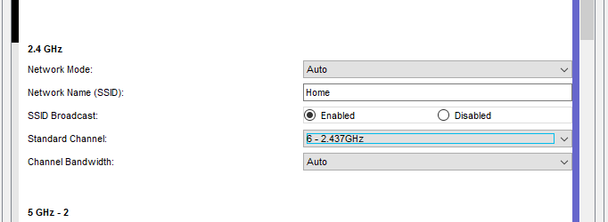
d. Chane the Standard Channel to 6 – 2.437GHz

e. Disable 5GHz frequencies.
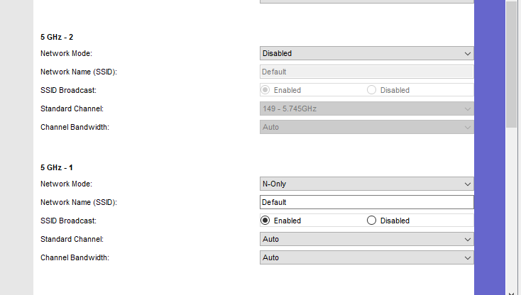

f. Save Settings
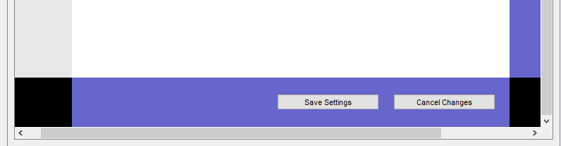

5. Configure wireless security settings

- Navigate to Wireless Wireless Security
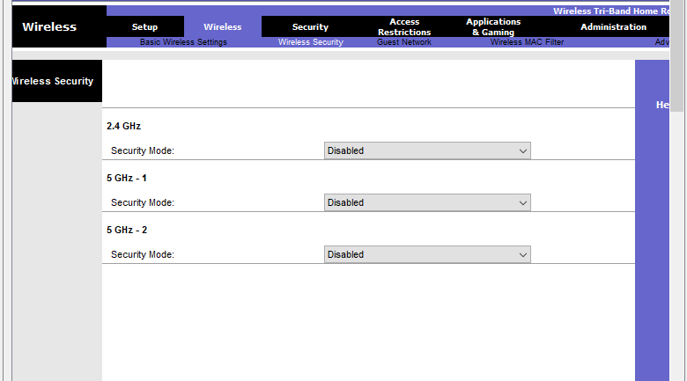

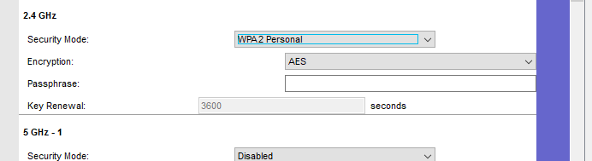
- Under the 2.4 GHz heading, select WPA2 Personal for the security mode.

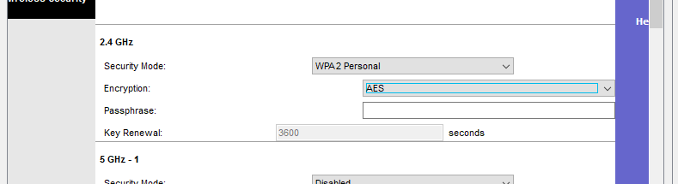
- Keep the default AES encryption settings

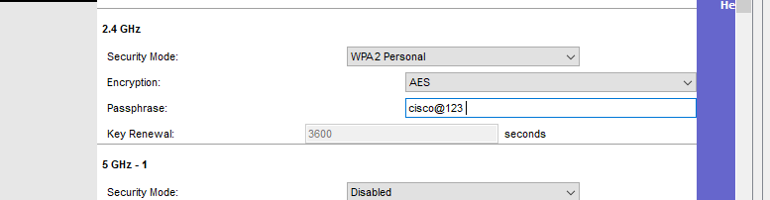
- Enter cisco@123 as the passphrase

- Save Settings



6. Connect the Wireless Clients
a. Turn on wireless interface in LP1
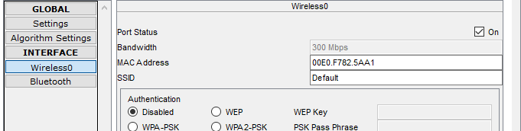

b. Navigate to PC Wireless on LP1
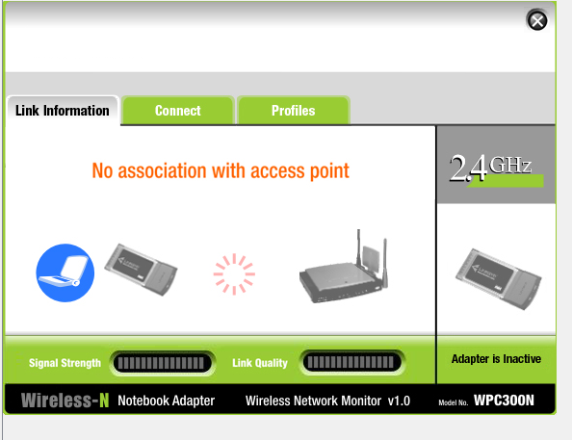

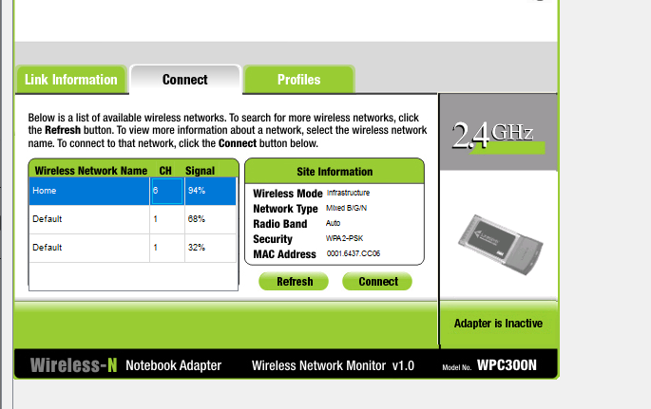
c. Select Connect tab and refresh as necessary, select the wireless network name Home

d. Enter passphrase and click connect.
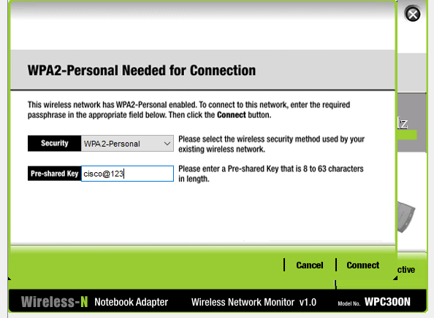

e. Open browser and try to access www.cisco.com
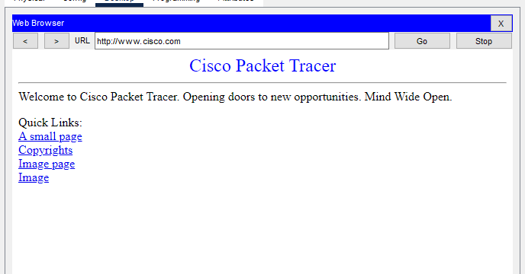

7. Connect wireless clients to an Access Point

- Connect Port 0 of AP with WR
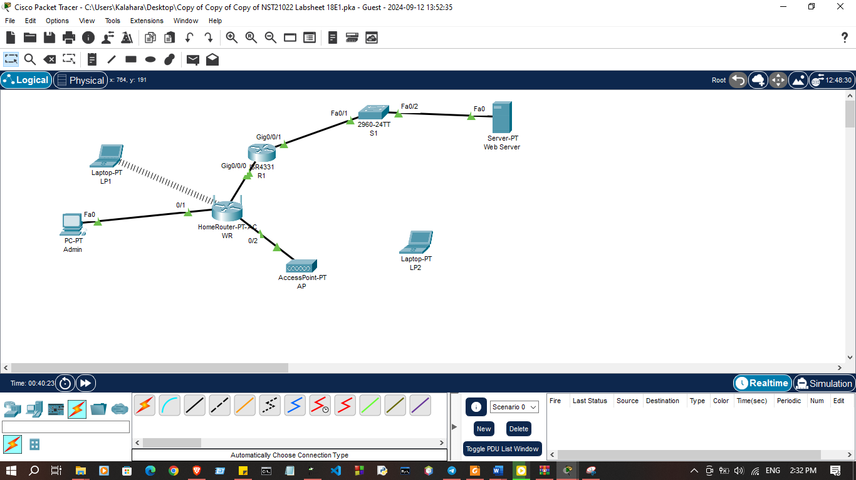

- In the config tab select Port 1

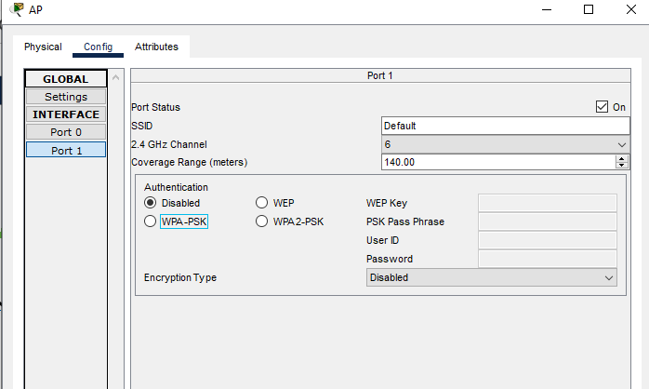

- Enter SSID as Home

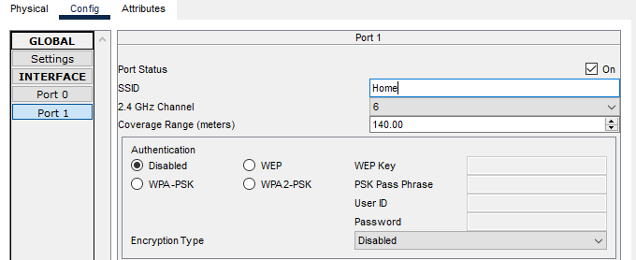

- Keep channel 1 if it is not change to channel 1
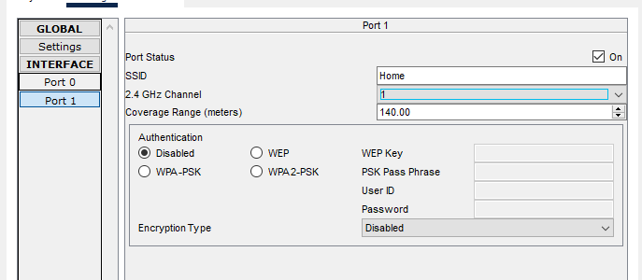

- Select WPA2-PSK and enter the passphrase cisco@123

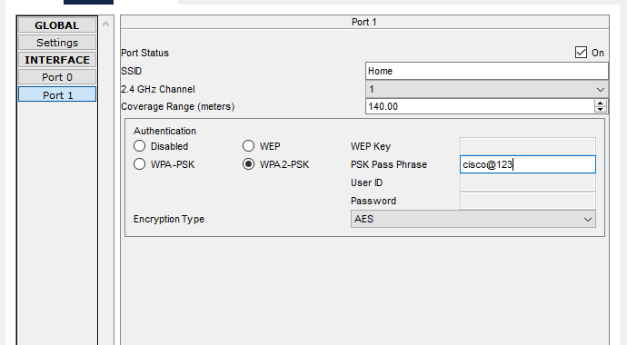

- Keep AES as the default encryption type.

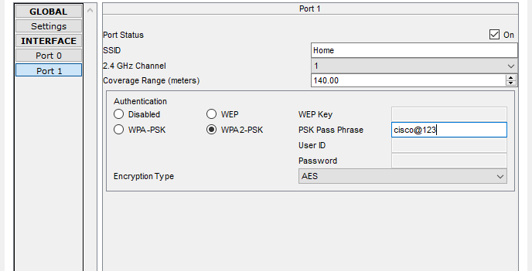

8. Connect the wireless clients

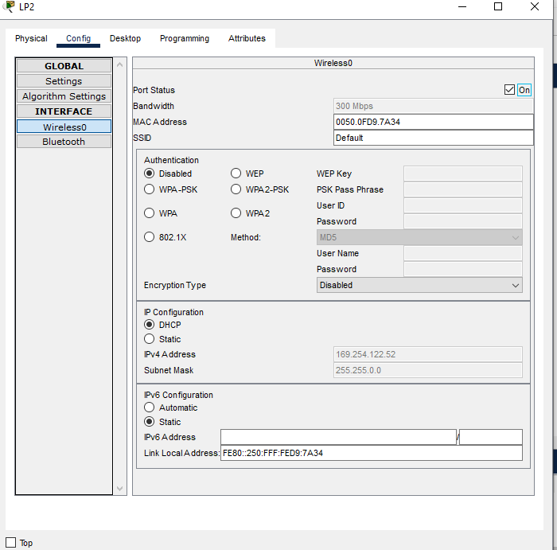
- On LP2 turn on wireless interface and go to PC Wireless

- Select Connect and refresh

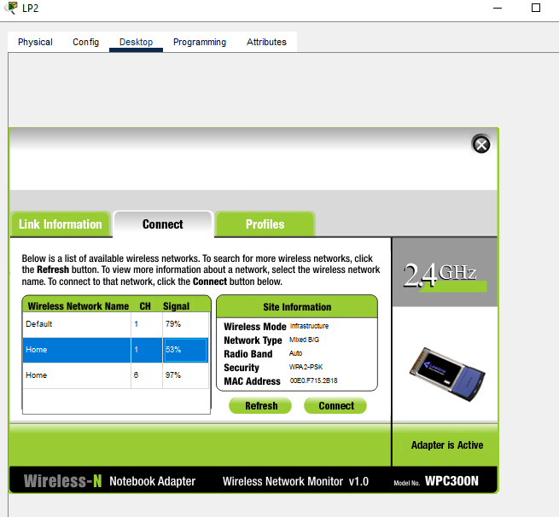

- Select Home with the strong single and connect

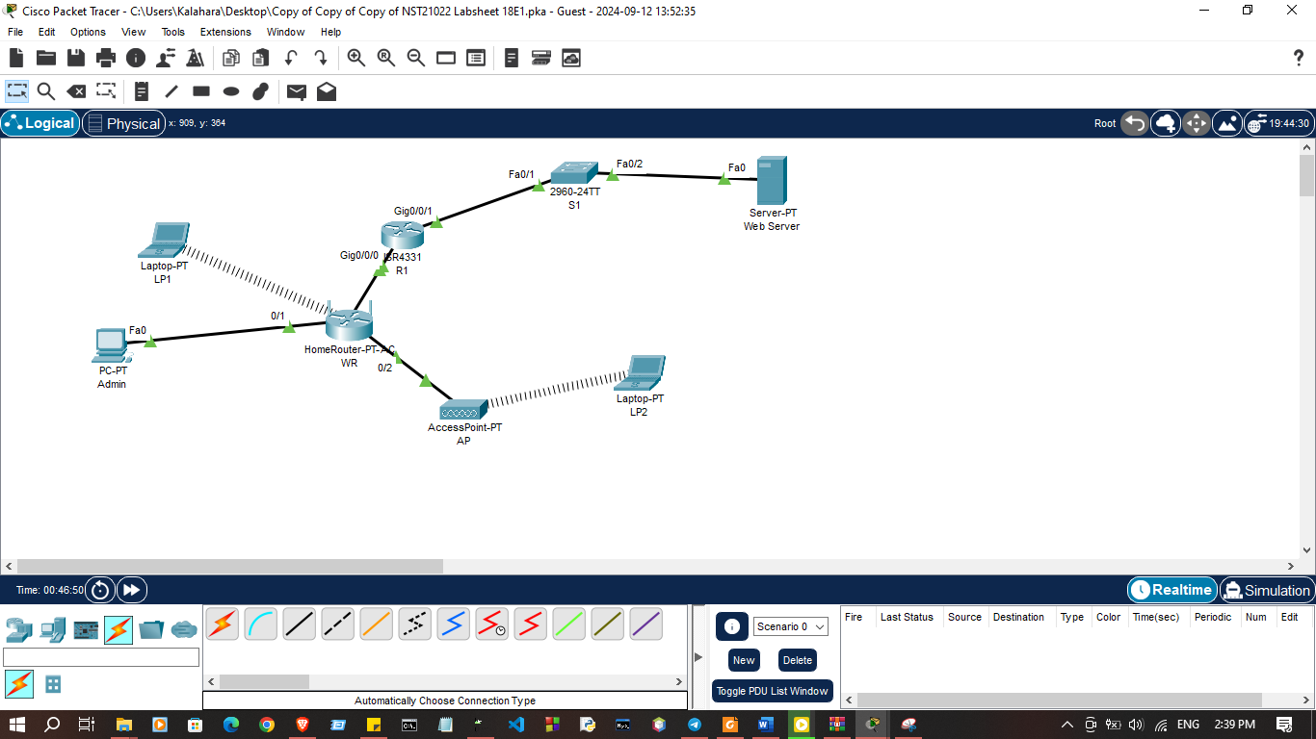

- Open web browser and try to access www.cisco.com

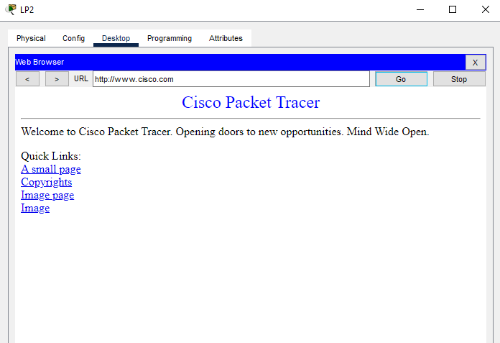

9. Change the WR access password

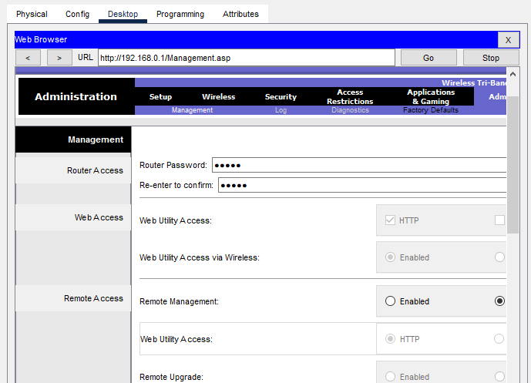
- Connect to the WR web interface

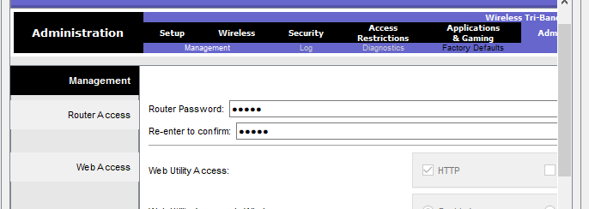
- Navigate to Administration Management and change the current router password to cisco

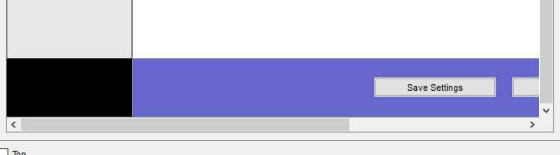
c. Save Settings

- Use admin as the username and new password when prompted to log in to the wireless router.

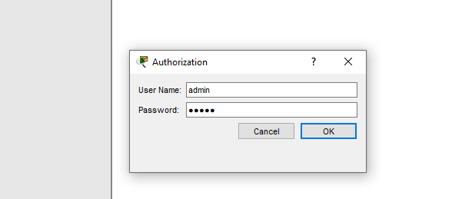

10. Change the DHCP address range in WR

a. Navigate to Setup Basic Setup
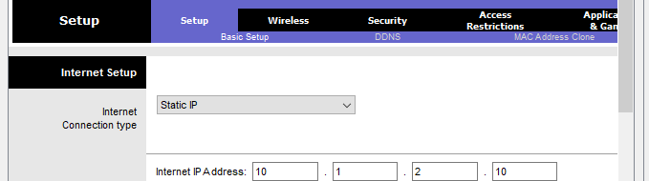

b. Scroll down the page to Network Setup
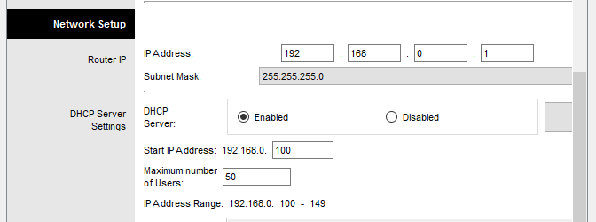

c. Change Router IP to 192.168.20.1
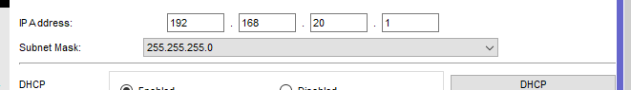

- Add 10.1.1.10 as the DNS Server with the DHCP settings
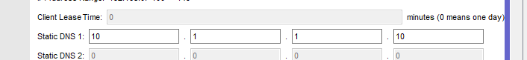

- Save Settings
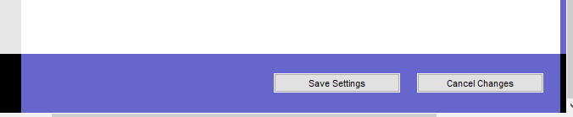

- Navigate to Admin PC’s Command Prompt
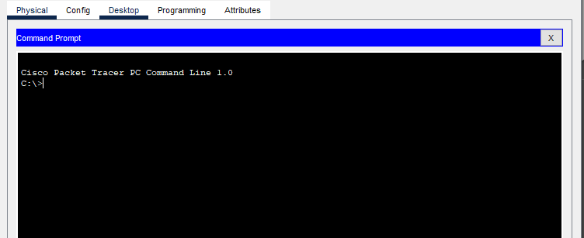

- Type ipconfig /renew to force Admin to re-acquire its IP information via DHCP
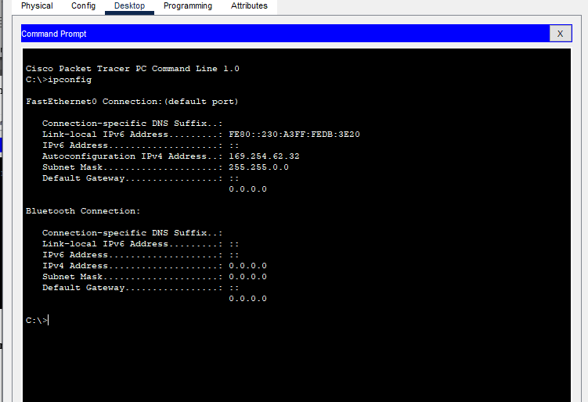
- Verity that you can still navigate to www.cisco.com
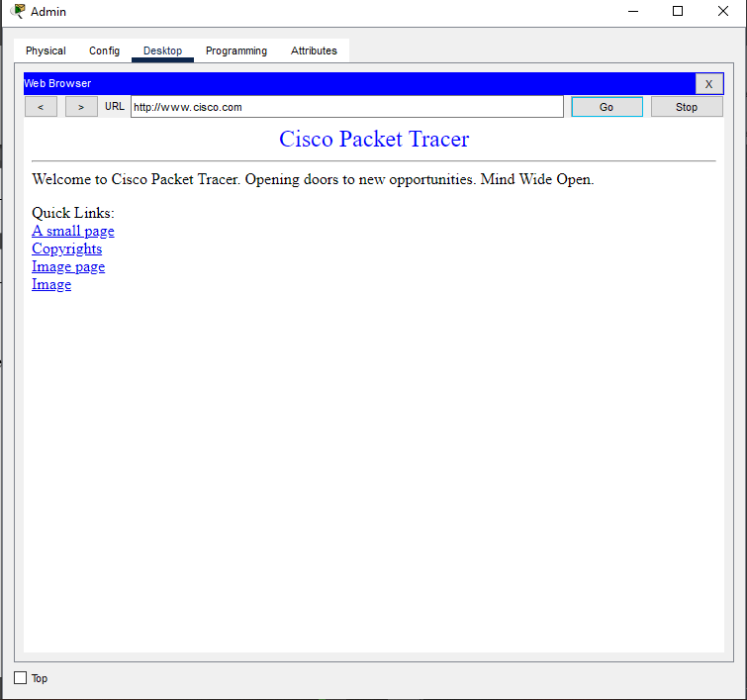

Exercise 02:
Configure a WPA2 Enterprise WLAN on the WLC
Use “NST21022 Lab sheet 18E2.pka” file
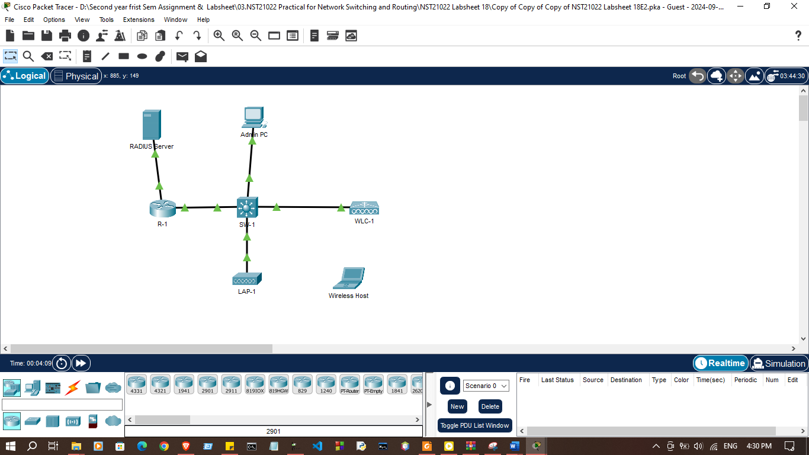
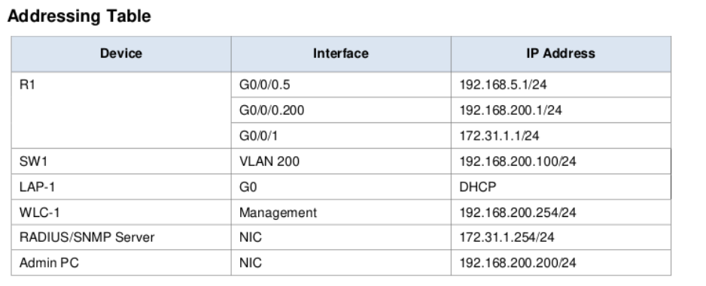

Part 1: Create a new WLAN

Step 1: Create a new VLAN interface.
Each WLAN requires a virtual interface on the WLC. These interfaces are known as dynamic interfaces. The virtual interface is assigned a VLAN ID and traffic that uses the interface will be tagged as VLAN traffic. This is why connections between the
APs, the WLC, and the router are over trunk ports. For the traffic from multiple WLANs to be transported through the network, traffic for the WLAN VLANs must be trunked.
- Open the browser from the desktop of Admin PC. Connect to the IP address of the WLC over HTTPS.
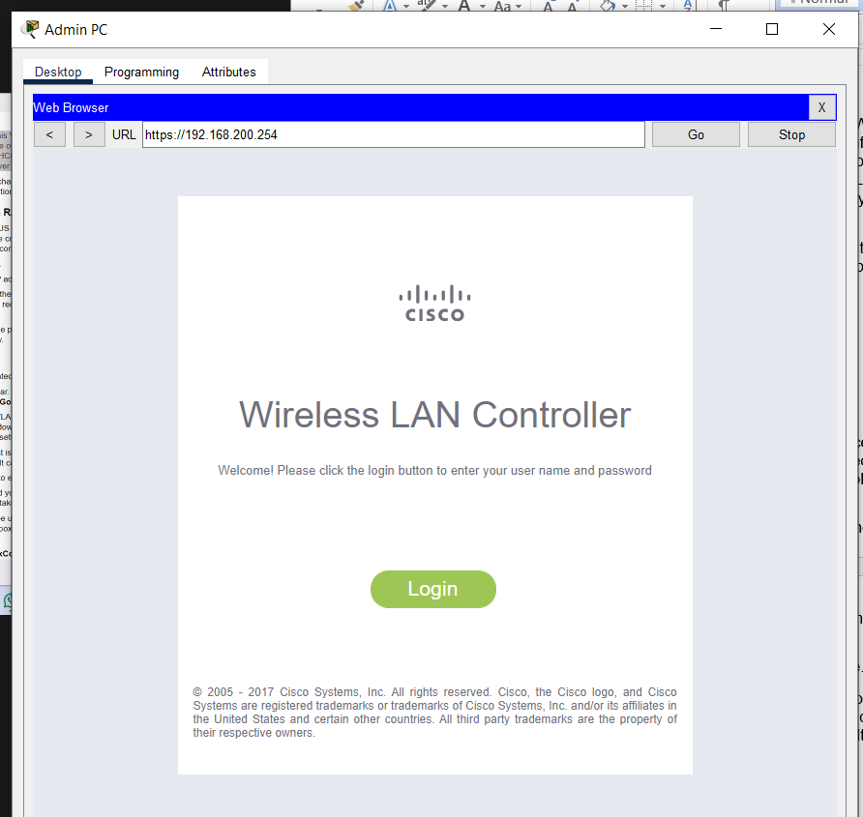
http https change
- Login with the username admin and password Cisco123.
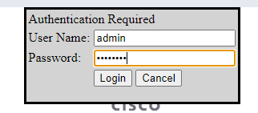
- Click the Controller menu and then click Interfaces from the menu on the left. You will see the default virtual interface and the management interface to which you are connected.
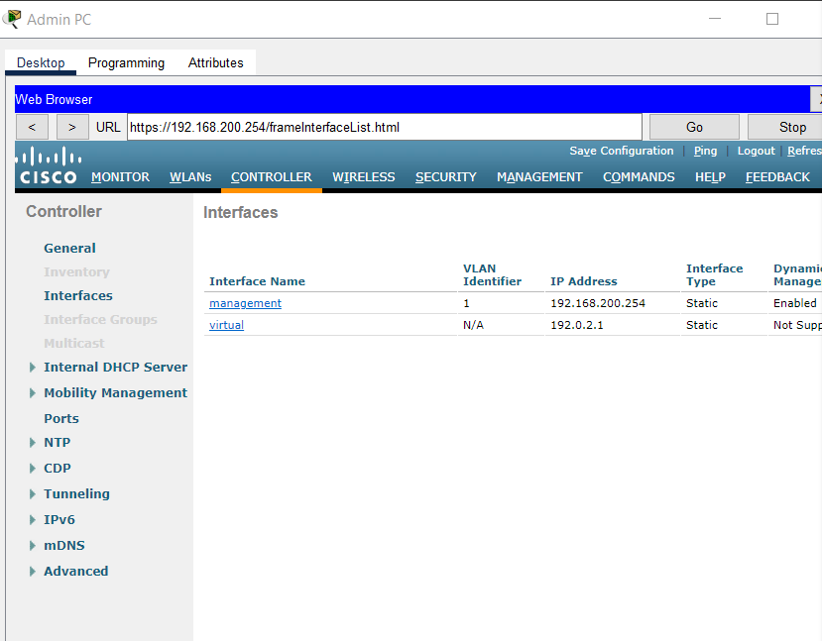
- Click the New button in the upper right-hand corner of the page. You may need to scroll the page to the right to see it.
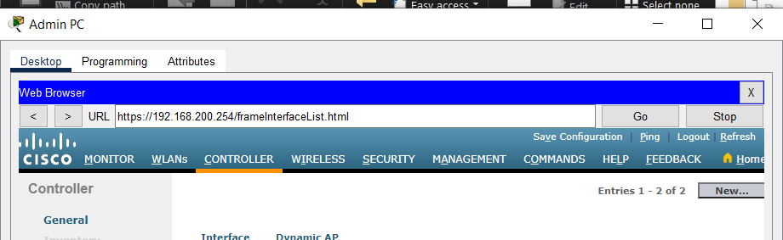
- Enter the name of the new interface. We will call it WLAN-5. Configure the VLAN ID as 5. This is the VLAN that will carry traffic for the WLAN that we create later. Click Apply. This leads to a configuration screen for the VLAN interface.
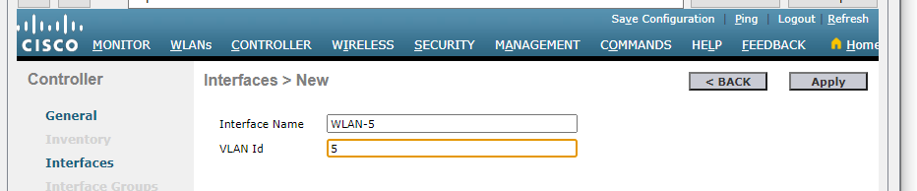
- First, configure the interface to use physical port number 1. Multiple VLAN interfaces can use the same physical port because the physical interfaces are like dedicated trunk ports.
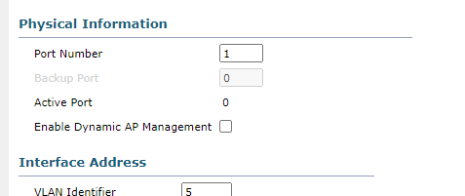
- Address the interface as follows:

IP Address: 192.168.5.254

Netmask: 255.255.255.0

Gateway: 192.168.5.1

Primary DHCP server: 192.168.5.1
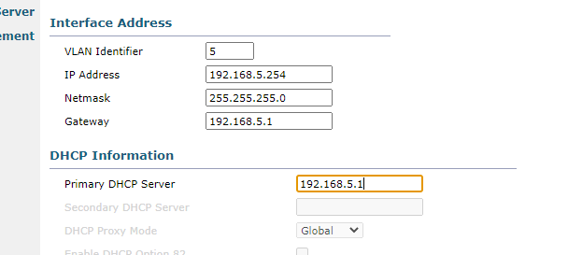
User traffic for the WLAN that uses this VLAN interface will be on the 192.168.5.0/24 network. The default gateway is the address of an interface on router R-1. A DHCP pool has been configured on the router. The address that we configure here for DHCP tells the WLC to forward all DHCP requests that it receivesfrom hosts on the WLAN to the DHCP server on the router.
- Be sure to click Apply to enact your changes and click OK to respond to the warning message. Click Save Configuration so that your configuration will be in effect when the WLC restarts.
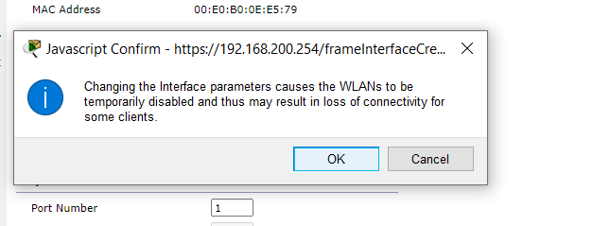
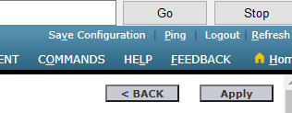

Step 2: Configure the WLC to use a RADIUS server.
WPA2-Enterprise uses an external RADIUS server to authenticate WLAN users. Individual user accounts with unique usernames and passwords can be configured on the RADIUS server. Before the WLC can use the services of the RADIUS server, the WLC must be configured with the server address.
- Click the Security menu on the WLC.
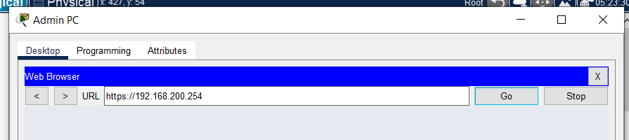
- Click the New button and enter the IP address of the RADIUS server in the
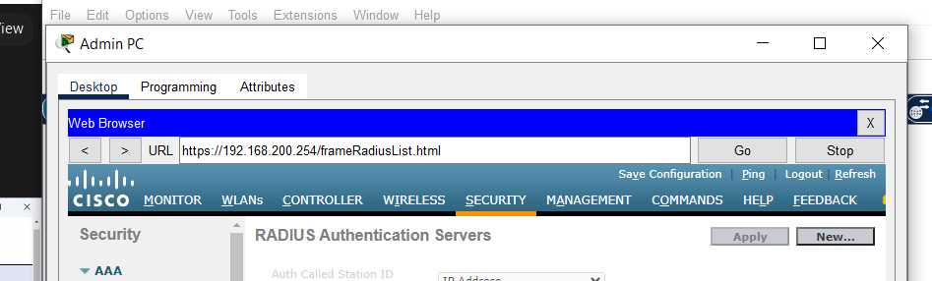
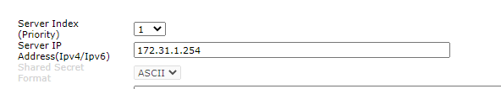
Server IP Address field.
- The RADIUS server will authenticate the WLC before it will allow the WLC to access the user account information that is on the server. This requires a shared secret value. Use Cisco123. Confirm the shared secret and click Apply.
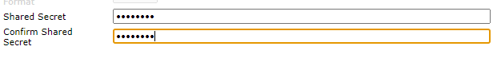
Note: It is not a good practice to reuse passwords. This activity reuses passwords only to make the activity easier for you to complete and review.
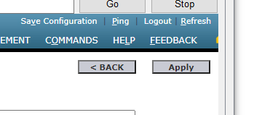

Step 3: Create a new WLAN.
Create a New WLAN. Use the newly created VLAN interface for the new WLAN.
- Click the WLANs entry in the menu bar. Locate the dropdown box in the upper right-had corner of the WLANs screen. It will say Create New. Click Go to create a new WLAN.
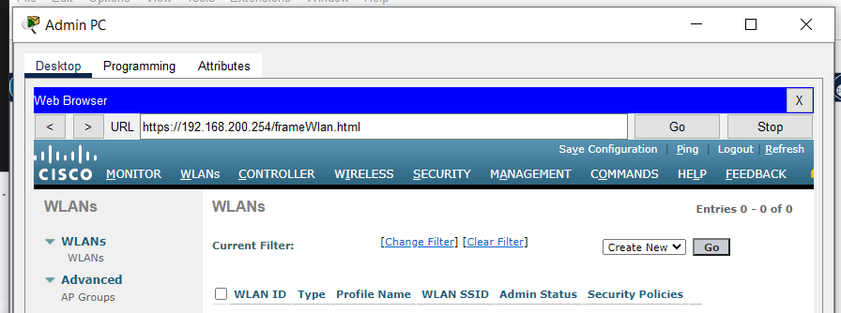
- Enter the Profile Name of the new WLAN. Use the profile name Floor 2 Employees. Assign an SSID of SSID-5 to the WLAN. Change the ID drop down to 5. Hosts will need to use this SSID to join the network. When you are done, click Apply to accept your settings.
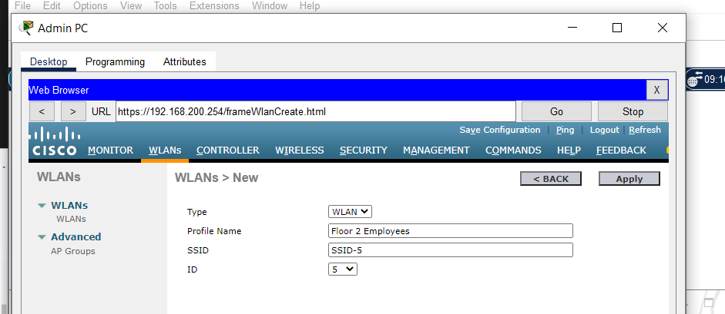
Note: The ID is an arbitrary value that is used as a label for the WLAN. In this case, we configured it as 5 to be consistent with VLAN for the WLAN. It could be any available value.
- Click Apply so that the settings go into effect.
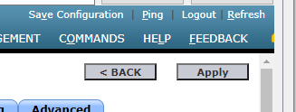
- Now that the WLAN has been created you can configure features of the network. Click Enabled to make the WLAN functional. It is a common mistake to
accidentally skip this step.
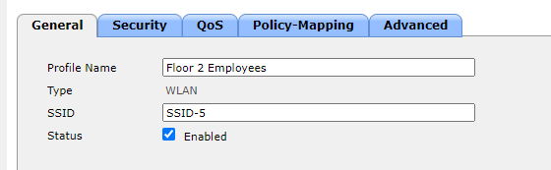

- Choose the VLAN interface that will be used for the new WLAN. The WLC will use this interface for user traffic on the network. Click the drop-down box for Interface/Interface Group (G). Select the interface that we created in Step 1.
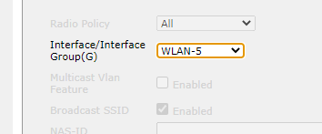
- Go to the Advanced tab. Scroll to FlexConnect section of the interface.
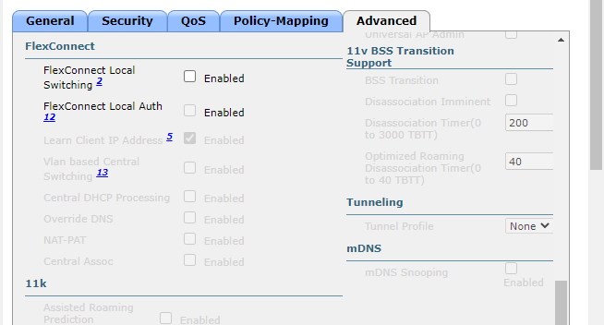

Click to enable FlexConnect Local Switching and FlexConnect Local Auth.
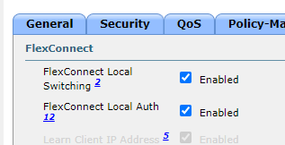
- Click Apply to enable the new WLAN. If you forget to do this, the WLAN will not operate.
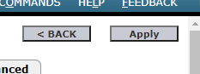

Step 4: Configure WLAN security.
Instead of WPA2-PSK, we will configure the new WLAN to use WPA2-Enterprise.
- Click the WLAN ID of the newly created WLAN to continue configuring it, if necessary.


- Click the Security tab. Under the Layer 2 tab, select WPA+WPA2 from the dropdown box.
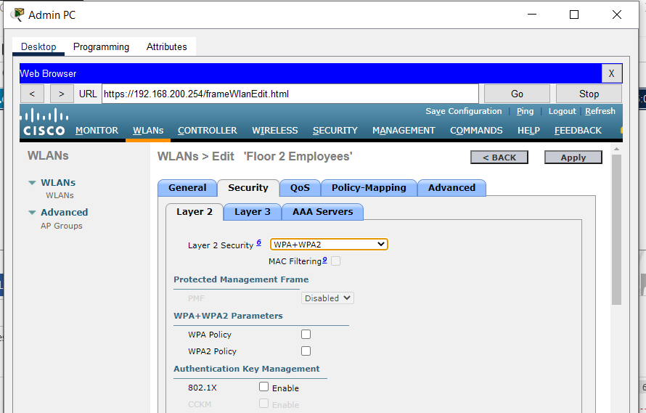
- Under WPA+WPA2 Parameters, enable WPA2 Policy. Click 802.1X under Authentication Key Management. This tells the WLC to use the 802.1X protocol to authenticate users externally.
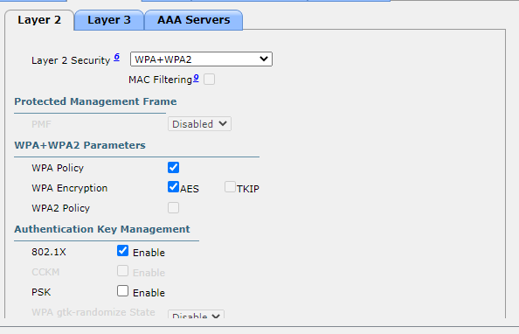
- Click the AAA Servers tab. Open the drop-down next to Server 1 in the
Authentication Servers column and select the server that we configured in Step 2.
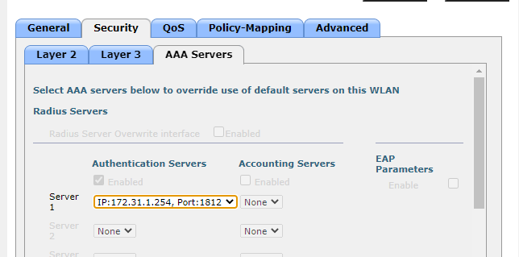
- Click Apply to enact this configuration. You have now configured the WLC to use the RADIUS sever to authenticate users that attempt to connect to the WLAN.
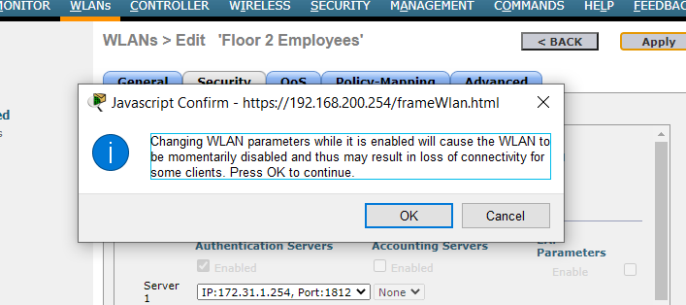

Part 2: Configure a DHCP Scope and SNMP Step 1: Configure a DHCP Scope.
The WLC offers its own internal DHCP server. Cisco recommends that the WLAN DHCP server not be used for high-volume DHCP services, such as that required by larger user WLANs. However, in smaller networks, the DHCP server can be used to provide IP addresses to LAPs that are connected to the wired management network.
- Should be connected to the WLC GUI from Admin PC.
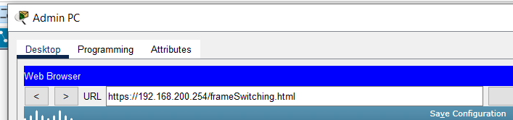
- Click the Controller menu and then click Interfaces.
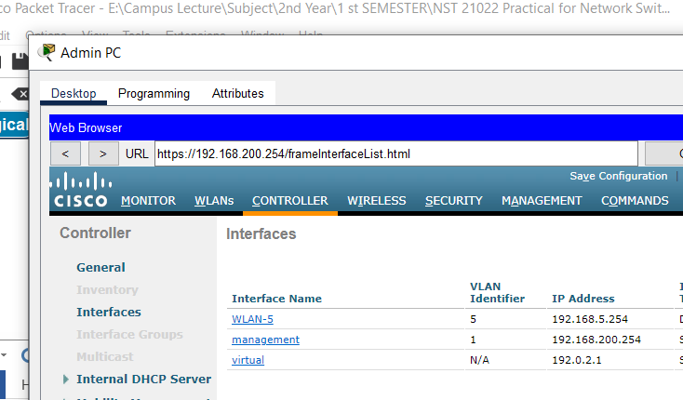
- Click the management Interface. Record its addressing information here.
IP address:
Netmask:
Gateway:
Primary DHCP server:
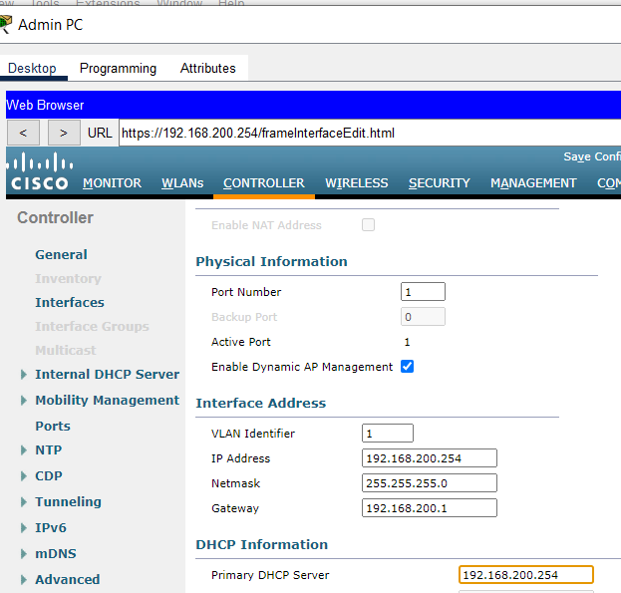

- We want the WLC to use its own DHCP sever to provide addressing to devices on the wireless management network, such as lightweight APs. For this reason, enter the IP address of the WLC management interface as the primary DHCP server address. Click Apply. Click OK to acknowledge any warning messages that appear.
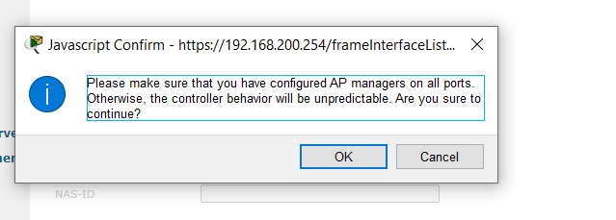
- In the left-hand menu, expand the Internal DHCP Server section. Click DHCP

Scope.
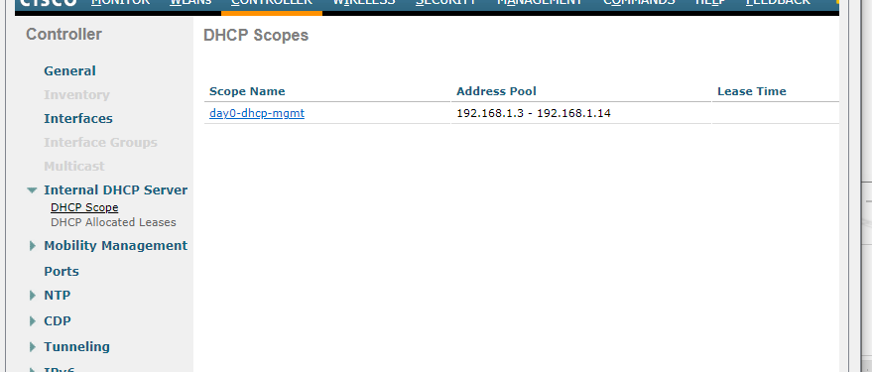
- To create a DHCP scope, click the New... button.
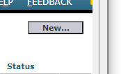
- Name the scope Wired Management. You will configure this DHCP scope to provide addresses to the wired infrastructure network that connects the Admin PC, WLC-1, and LAP-1.
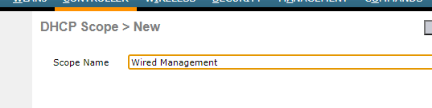
- Click Apply to create the new DHCP scope.

- Click the new scope in the DHCP Scopes table to configure addressing
information for the scope. Enter the following information.

Pool Start Address: 192.168.200.240

Pool End Address: 192.168.200.249

Status: Enabled
Provide the values for Network, Netmask, and Default Routers from the information you gathered in Step 1.3. (Step 1 . 3 eke Netmask add krnna)
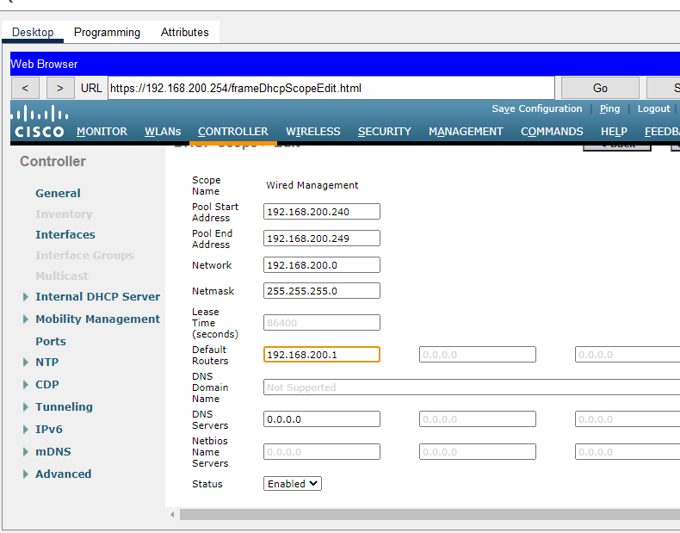

- Click Apply to activate the configuration. Click Save Configuration in the upper-right-hand corner of the WLC interface to save your work so that it is available when the WLC restarts.
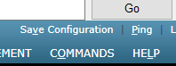
The internal DHCP server will now provide an address to LAP-1 after a brief delay. When LAP-1 has its IP address, the CAPWAP tunnel will be established and LAP-1 will be able to provide access to the Floor 2 Employees (SSID-5) WLAN. If you move the mouse over LAP-1 in the topology, you should see its IP address, the status of the CAPWAP tunnel, and the WLAN that LAP-1 is providing access to.

Step 2: Configure SNMP.
- Click the Management menu in the WLC GUI and expand the entry for SNMP in the left-hand menu.
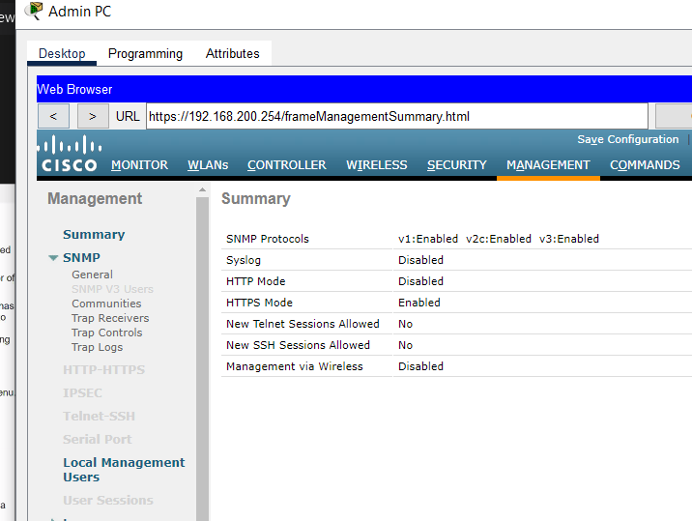

Click Trap Receivers and then New...
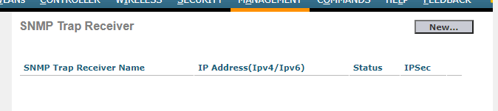

3. Enter the community string as WLAN_SNMP and the IP address of the server at

172.31.1.254.
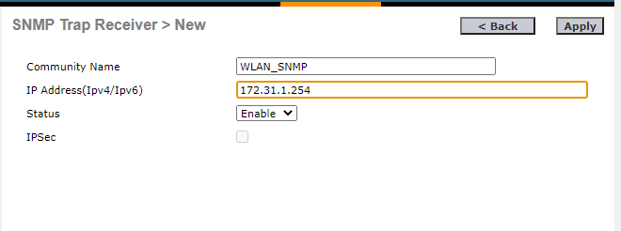
- Click Apply to finish the configuration.

Part 3: Connect Hosts to the Network

Step 1: Configure a host to connect to the enterprise network.
In the Packet Tracer PC Wireless client app, you must configure a WLAN Profile in order to attach to a WPA2-Enterprise WLAN.
- Click Wireless Host and open the PC Wireless app.
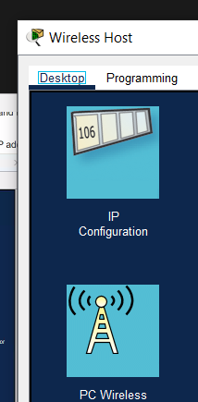

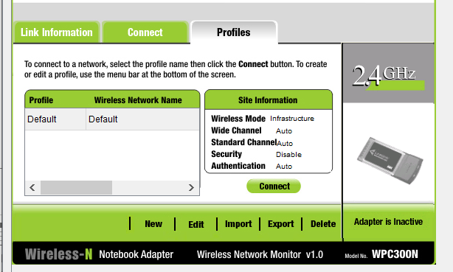
- Click the Profiles tab and then click New to create a new profile. Name the profile WLC NET.

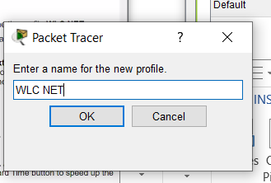
- Highlight the Wireless Network Name for the WLAN that we created earlier and click Advanced Setup.
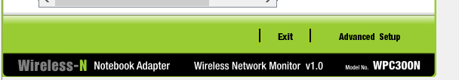
- Verify that the SSID for the wireless LAN is present and then click Next. Wireless Host should see SSID-5. If it does not, move the mouse over LAP-1 to verify that it is communicating with the WLC. The popup box should indicate that LAP-1 is aware of SSID-5. If it is not, check the WLC configuration. You can also manually enter the SSID.
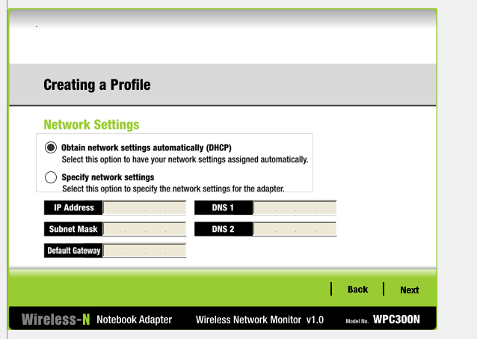
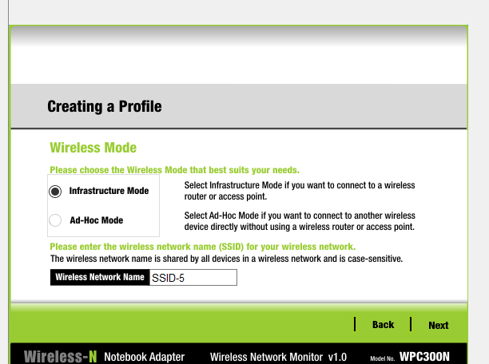
- Verify that the DHCP network setting is selected and click Next.
- In the Security drop down box, select WPA2-Enterprise. Click Next.
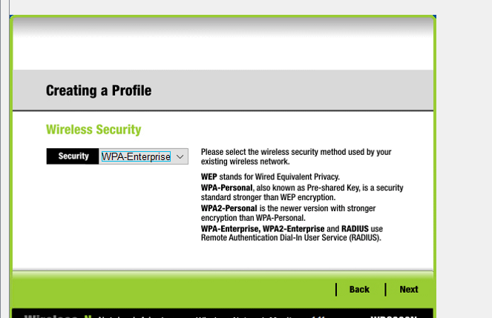
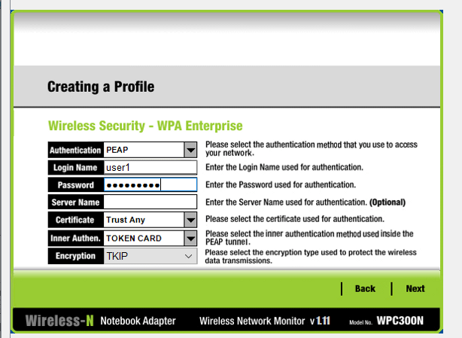
- Enter login name user1 and the password User1Pass and click Next.

- Verify the Profile Settings and click Save.
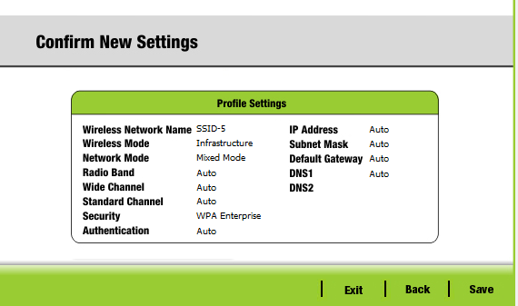
- Select the WLC NET profile and click the Connect to Network button. After a brief delay, you should see the Wireless Host connect to LAP-1. You can click the Fast Forward Time button to speed up the process if it seems to be taking too long.
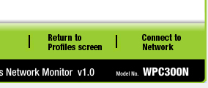
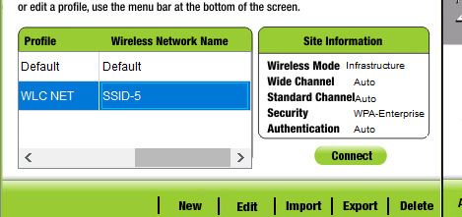
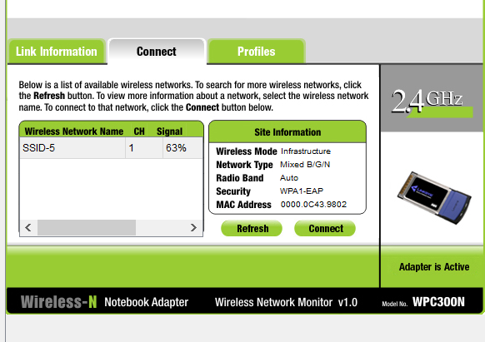
Select and Click Connect Refresh and select wireless network and connect
- Confirm that Wireless Host has connected to the WLAN. Wireless Host should receive an IP address from the DHCP server that is configured for hosts on R1. The address will be in the 192.168.5.0/24 network. You may need to click the Fast Forward Time button speed up the process.

Step 2: Test Connectivity.
- Close the PC Wireless app.
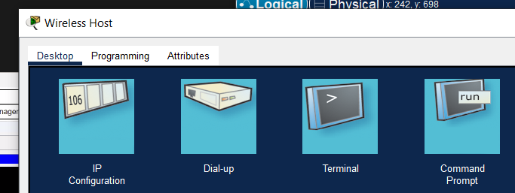
- Open a command prompt and confirm that Wireless Host laptop has obtained an
IP address from the WLAN network.
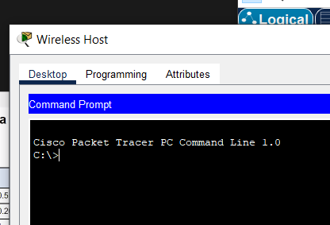
- Ping the default gateway, SW1, and the RADIUS server. Success indicates full connectivity within this topology.
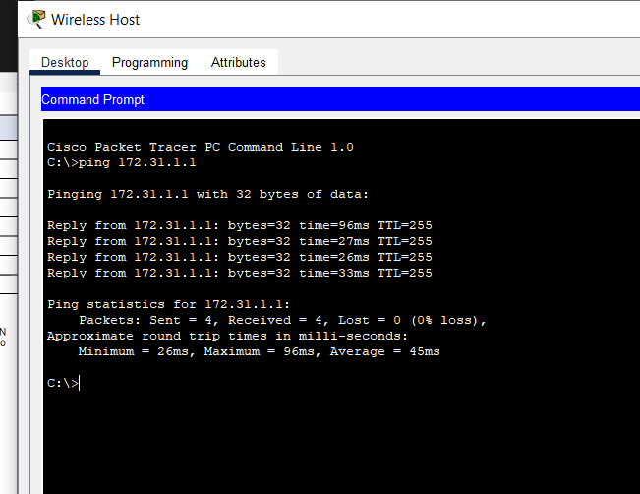

Discussion
- In this lab session, we focused on configuring and securing a wireless network using a wireless router and Wireless LAN Controller (WLC). First, we set up a wireless router and connected wireless devices to it, ensuring basic wireless connectivity. To extend coverage, we added an access point to expand the network's reach. On the WLC, we configured a new VLAN interface to segment network traffic, then created a new WLAN for wireless clients. We also set up a new DHCP scope on the WLC’s internal DHCP server to automatically assign IP addresses to wireless clients. To improve monitoring, we configured SNMP settings on the WLC, followed by integrating a RADIUS server for secure user authentication. Finally, we secured the WLAN using WPA2-Enterprise and connected hosts to the new WLAN, ensuring both security and smooth wireless access across the network.

